
Year 10

Term Test 2 Pathway 1

Finance, Trigonometry, Statistics, Linear Quadratics

Resources allowed: Calculator and 1 x A4 page double side
Name: ______________________ Class: ______ Time: 55 minutes Total Marks: ____/54
Show working and answers on this sheet. Show working in sufficient detail to support your answers. Incorrect answers without supporting reasoning may be allocated zero marks.

- [7 marks: 1, 1, 2, 2, 3]
- Find the simple interest charged on $50 000 borrowed for 3 years at 8.5% pa.

- How much would need to be invested at 6.5% pa for 6 months in order to earn $500 interest

- $25 500 is invested at 5.3% pa compounded yearly. What will be the final amount after 4 years (round to the nearest dollar)?

d) State which option produces the better outcome over 5 years? Show your working.
i) $100 000 invested at 9% pa compounded yearly?
ii) $100 000 invested at 9% pa compounded monthly?

- [14 marks: 1, 2, 2, 2, 1, 3, 3]

a) Use Pythagoras’ theorem to find the length of the unknown side (round to two decimal places):
2.3
x
4.8

b) Use the sin, cos, or tan ratio to find the unknown (round to two decimal places):
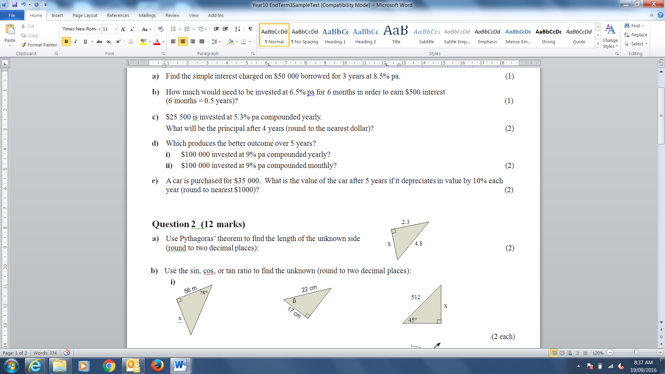

i) ii)

- A television mast is secured by a single wire cable which is 60 metres long. The cable is fastened to the top of the mast and to the ground. It makes an angle of 58° with the ground. Find the height of the mast.

- From the top of a 200 m tower, the angle of depression to a fire is 5°. How far away is the fire?

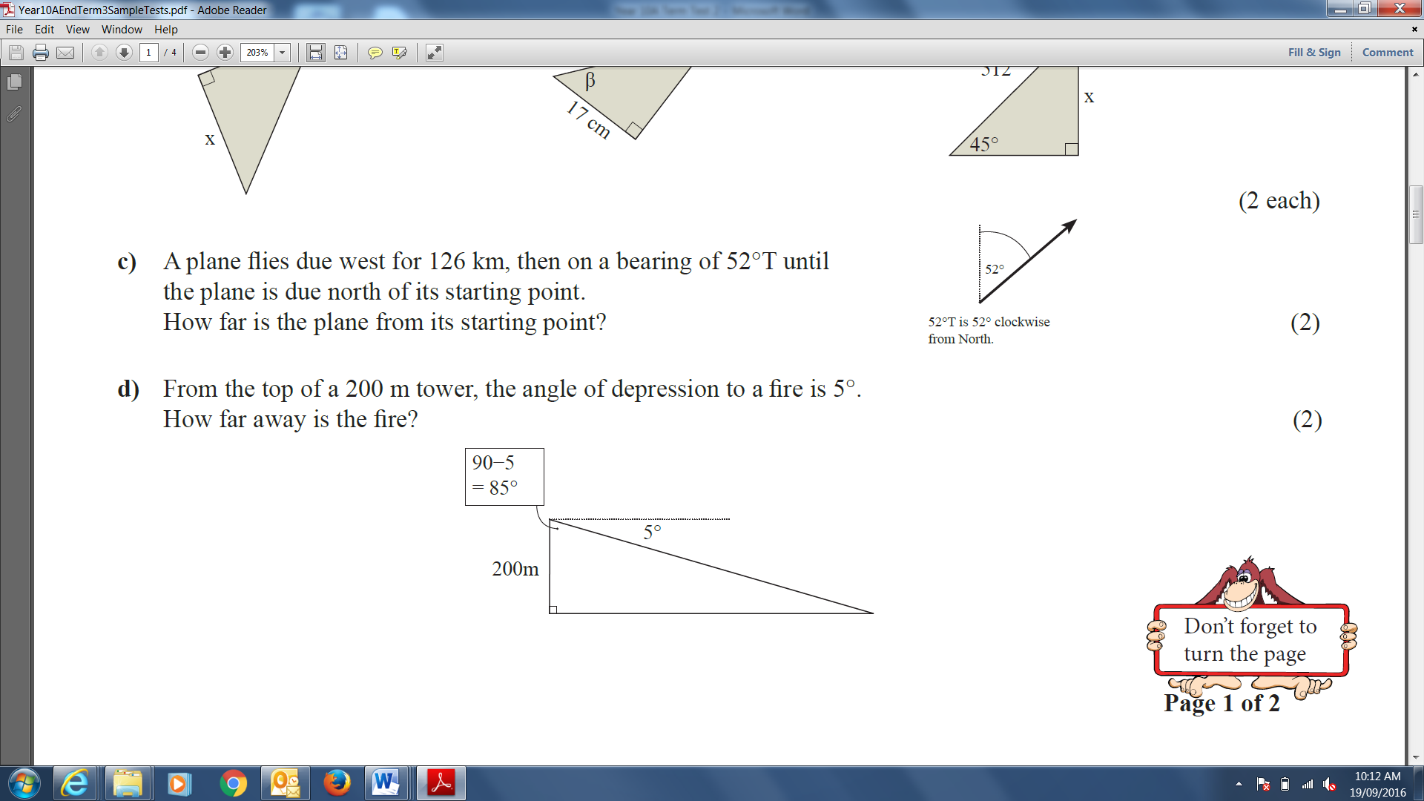

- A 4.5 m ladder rests against a tree on level ground and forms a 75°angle of elevation. Where is the correct location of the 75° angle?
- Between the ladder and the ground
- Between the ladder and the tree
- Between the tree and the ground
- It is not possible to place a 75° angle on such a figure.

- Error Analysis: Consider the following problem, which Stephanie and Adam are both trying to solve: “A cat, who has climbed a tree, looks down at a dog at a 28° angle of depression. If the dog is 34 meters from the base of the tree, how high up is the cat?” The first steps of their work are shown below. Analyze their work and determine who, if anyone, has set it up correctly.

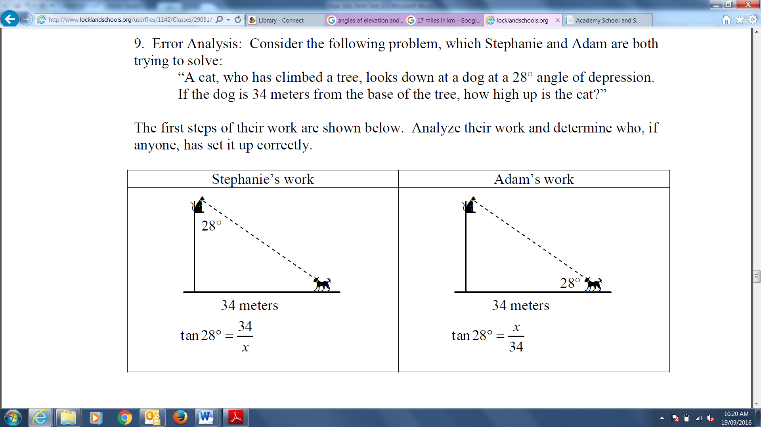

How high up in the tree is the cat?

- A person starts out 27 km from the base of a tall mountain, and looks up at a 4° angle of elevation to the top of the mountain. When they move 19 km closer to the base of the mountain, what will be their angle of elevation when they look to the top? Answer to the nearest degree.

- [14 marks: 1, 3, 1, 6, 5]
- Which of these graphs would touch the x-axis but not cross it?
A y = x2 + 3x B y = x2 + 2x + 4
C y = x2 + 10x + 20 D y = x2 + 8x + 16

- Answer the following:
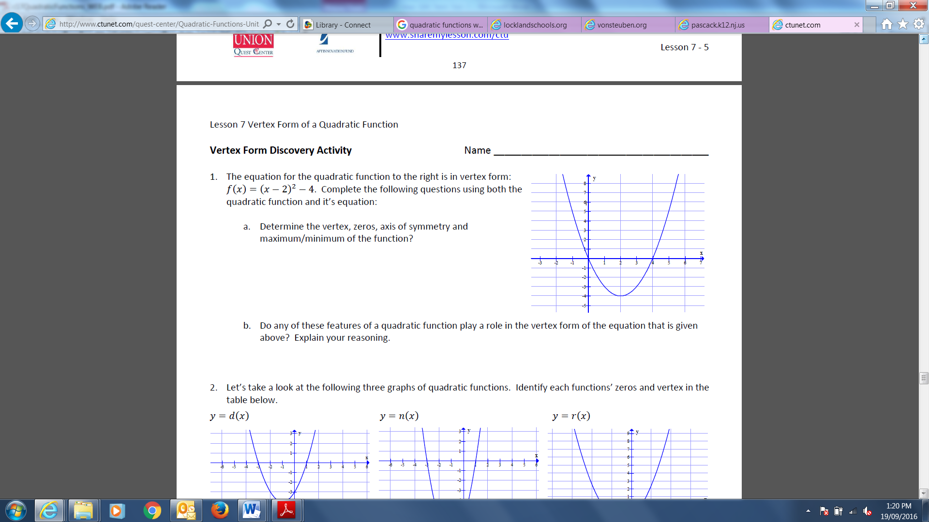
i) ii)

Equation of the axis of symmetry: _____________ Equation of the axis of symmetry: _____________
Coordinates of the turning point: ______________ Coordinates of the turning point: ______________
Maximum or Minimum? _____________________ Maximum or Minimum? _____________________

- The y-intercept of the graph of $y= -x^{2}-6$ is:
A 1 B -1 C 6 D -6

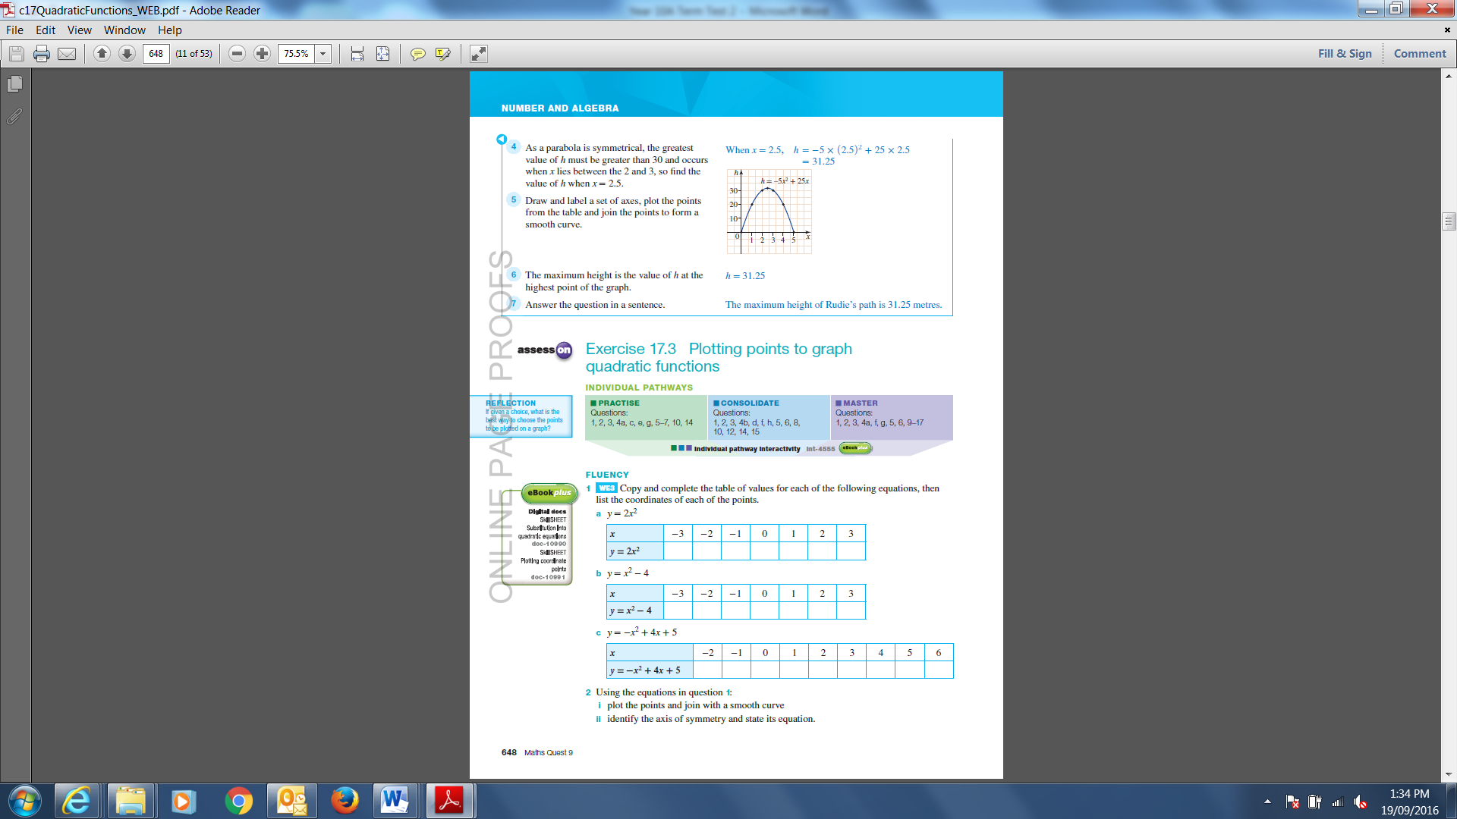

- Complete the tables and then plot the points and join with a smooth curve on the grid provided.

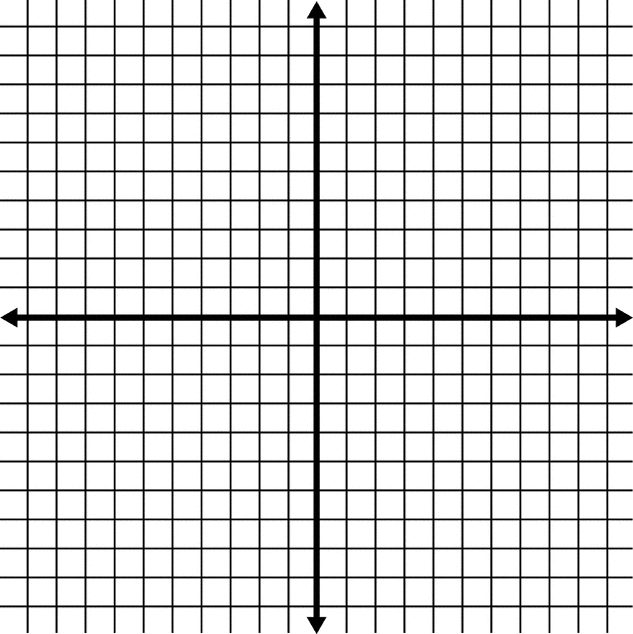

- Without using a table of values, sketch the following parabola on the axis provided.
y = x² + 8x + 7



- [19 marks: 4, 3, 8, 4]
- Draw the boxplot for the following set of data by first completing the 5 number summary.
Mathematics scores for a Year 10 end of Year Examination (%)
Scores | 42 | 47 | 52 | 55 | 55 | 58 | 61 | 62 | 64 | 65 | 67 | 68 | 72 | 80 | 88 | 92

b) State whether any relationship is indicated by each of the following scatter plots, and if so, state the kind of relationship shown.
i) ii) iii)
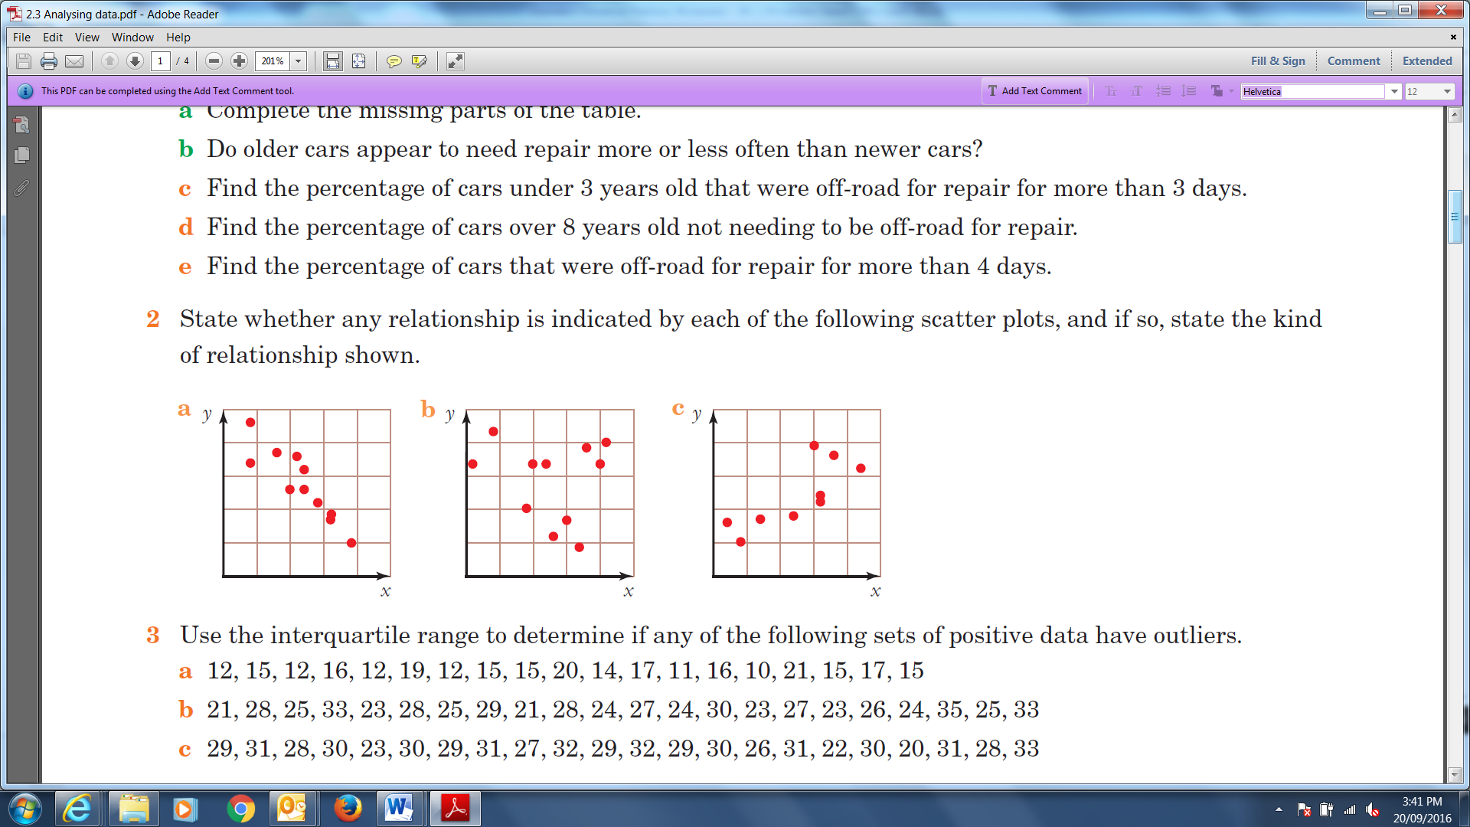



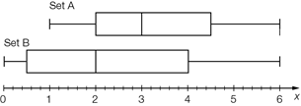
- The following boxplots are mathematics quiz scores, out of 8, for two classes, A and B.

- For each class find the five number summary and the interquartile range (IQR)

 | Set A | Set B
Minimum
Q₁
Median
Q₃
Maximum
IQR

ii) Compare the statistics for the two classes. Which did the best? Justify your answer.

- Calculate the mean and standard deviation of the following sets of data:
i) 45, 58, 48, 54, 51, 57

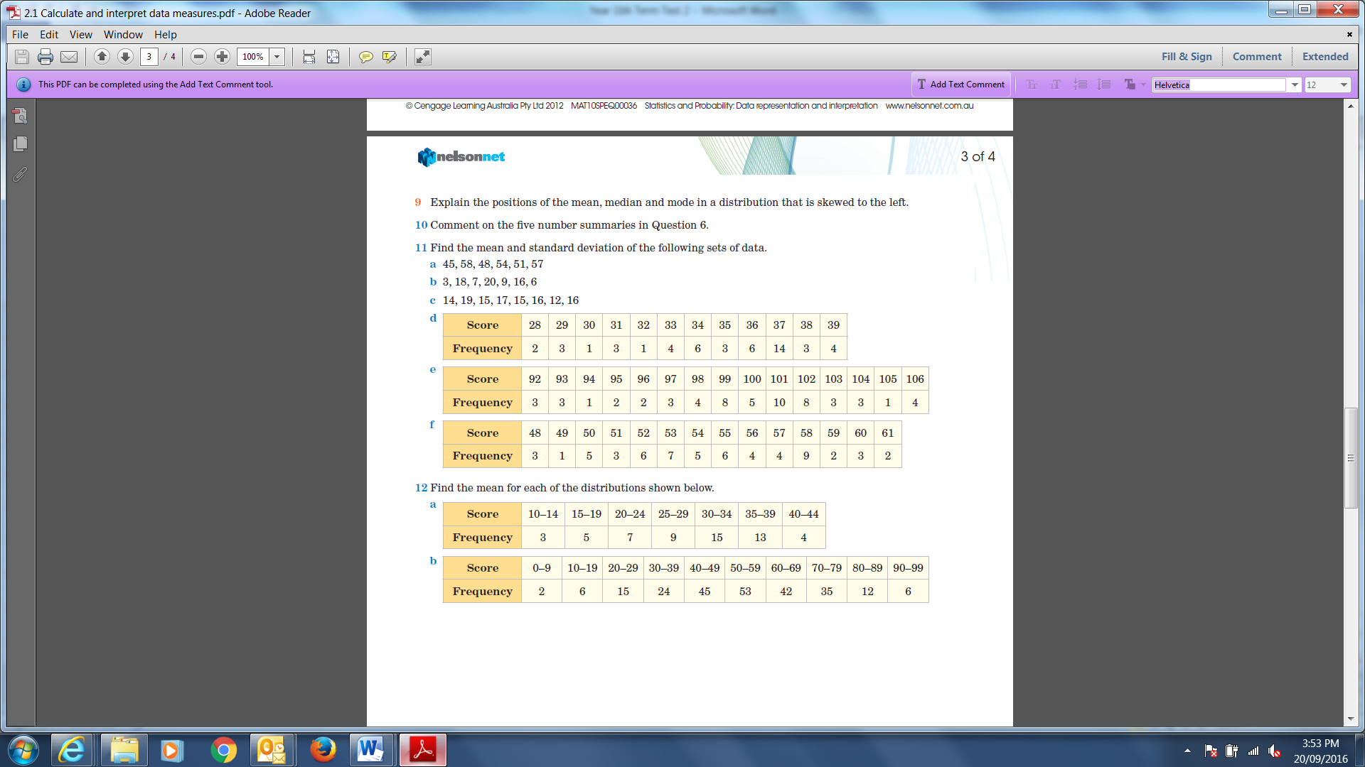
ii)

~End of Test~

